**ASSIGNMENT 4**

**TEAM ID:PNT2022TMID49801**

**# Case (i) : Distance < 100cm**

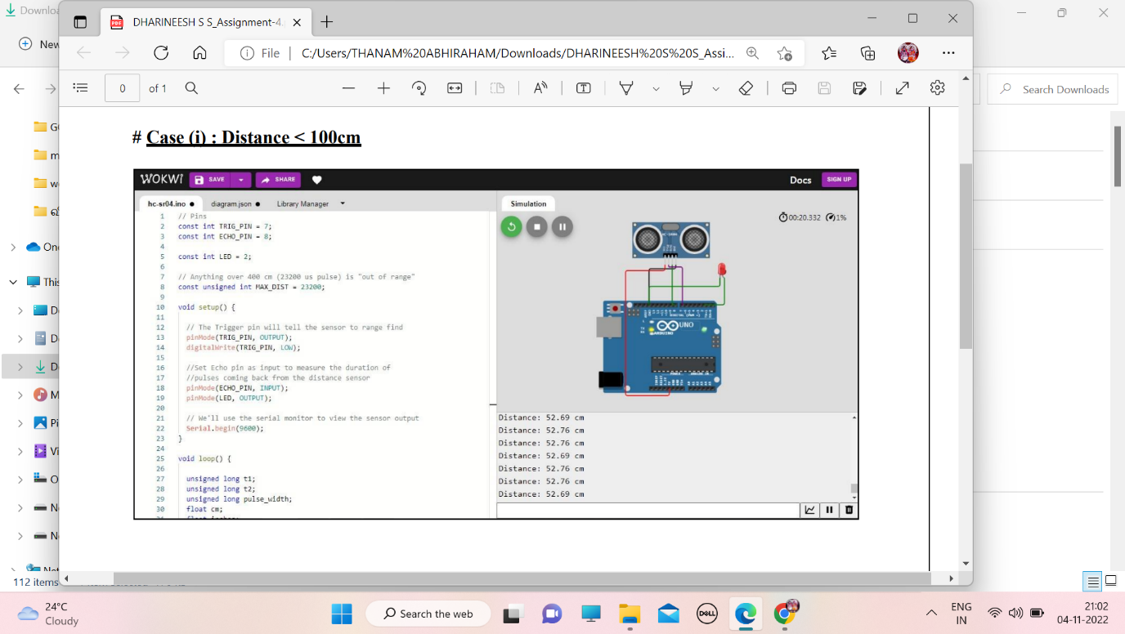

**# Case (ii) : Distance > 100cm**

